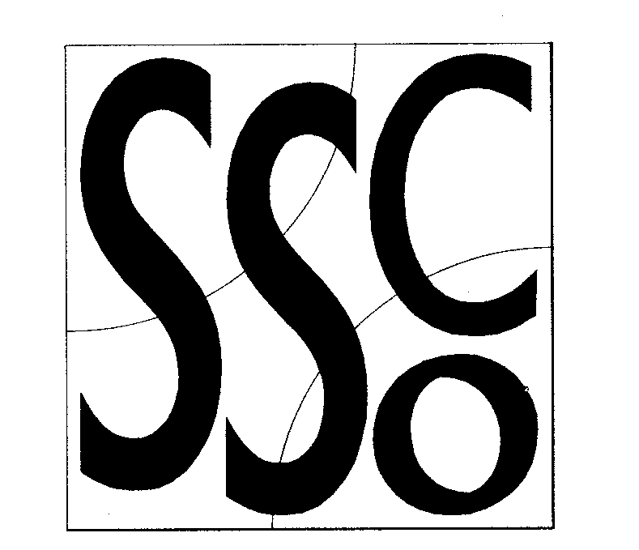

Teaching Points
Keep your eye on the target.
Swing the arm using a pendulum swing.
At release the hand should point at the target.
Step into the roll with the opposite foot.
Wait on the balls of your feet with knees bent, ready to move.

Watch the Ball
MULTI SKILL CARDS



Classification
Hand-eye coordination.

Equipment

Cones, balls, bibs and stopwatch.

Differentiation
Easier
- Decrease the distance between the pupils.
- Use a large ball to roll.
- Allow the pupils to roll using two hands.
- Allow the ball to bounce.
Harder
- Increase the distance between the pupils.
- The ball cannot bounce.
- Pupils may only use one hand to roll.
- Pupils can only stop the ball with one hand.
- Pupils have to try rolling with both hands.
- Introduce time limits.
- Increase the number of balls that are being used.
- Vary the speed of the roll.
- Vary the direction of the roll.
- Introduce another pair to incorporate defending and movement.
- Introduce a goal which pupils stand in and must defend.
- Introduce movement patterns to be used when defending the goal.

Activity/ Key Points

- Two pupils roll a ball to each other, stop it with both hands and then roll it back.

